Sphere Diameter
# Source: AI Source: Provided by: [Data Path: Persons Table -> ID Column: 1, Name_En Column: Motasem Essam] -> From: [ChatGPT] on [7/25/2026]
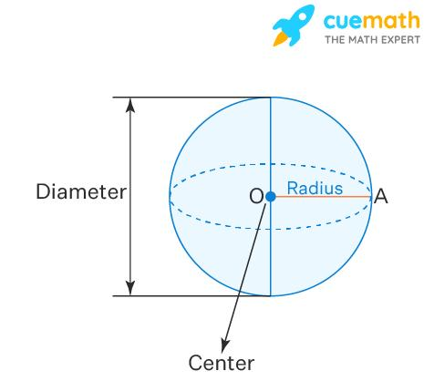
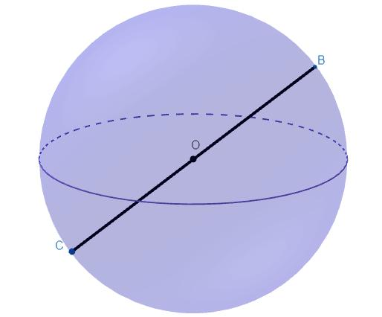
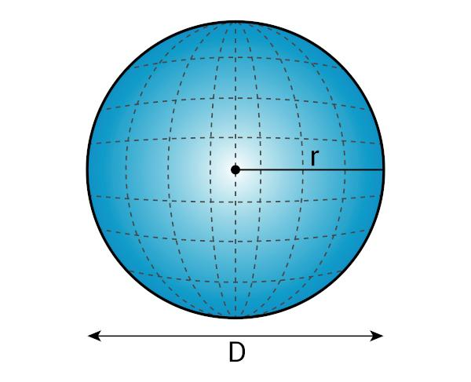

Definition
# Source: AI Source: Provided by: [Data Path: Persons Table -> ID Column: 1, Name_En Column: Motasem Essam] -> From: [ChatGPT] on [7/25/2026]
The diameter of a sphere is a line segment that passes through the sphere's center and has both endpoints on its surface.
The diameter is the longest straight-line segment that can be drawn between two points on a sphere's surface. Its length is exactly twice the sphere's radius.
If $O$ is the center of the sphere and $A$ and $B$ are opposite points on its surface, then $\overline{AB}$ is a diameter when $A$, $O$, and $B$ lie on the same straight line.
$$\boxed{D=2R}$$

Simple Definition
# Source: AI Source: Provided by: [Data Path: Persons Table -> ID Column: 1, Name_En Column: Motasem Essam] -> From: [ChatGPT] on [7/25/2026]
A sphere's diameter is a straight line segment that crosses the center and connects one side of the sphere to the opposite side.
- First endpoint: A point on the sphere's surface.
- Middle point: The sphere's center.
- Second endpoint: The opposite point on the surface.
- Length: Twice the radius.
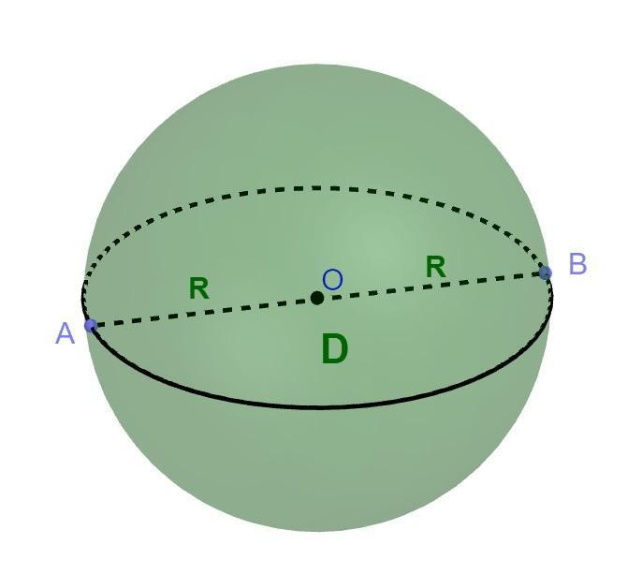

Geometric Representation
# Source: AI Source: Provided by: [Data Path: Persons Table -> ID Column: 1, Name_En Column: Motasem Essam] -> From: [ChatGPT] on [7/25/2026]
Consider a sphere with center $O$ and diameter endpoints $A$ and $B$.
$$A ⟷ O ⟷ B$$
The points lie on one straight line, with $O$ exactly halfway between $A$ and $B$.
The diameter is the complete segment $\overline{AB}$, while $\overline{OA}$ and $\overline{OB}$ are radius segments.
$$AO=OB=R$$
$$AB=AO+OB$$
Therefore:
$$\boxed{AB=D=2R}$$

Types of Sphere Diameter
# Source: AI Source: Provided by: [Data Path: Persons Table -> ID Column: 1, Name_En Column: Motasem Essam] -> From: [ChatGPT] on [7/25/2026]
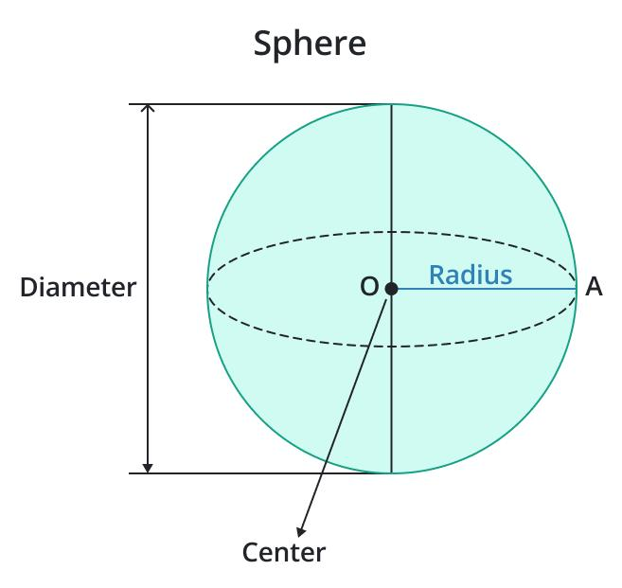

Geometric Diameter
# Source: AI Source: Provided by: [Data Path: Persons Table -> ID Column: 1, Name_En Column: Motasem Essam] -> From: [ChatGPT] on [7/25/2026]
A diameter is any segment through the center with both endpoints on the sphere's surface. A sphere has infinitely many possible diameters because the line can pass through the center in any direction.
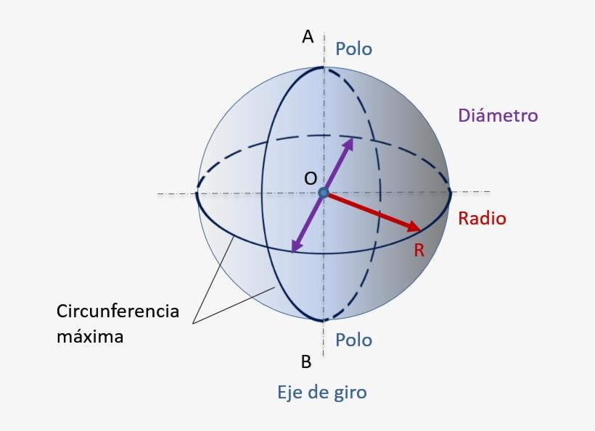

Polar Diameter
# Source: AI Source: Provided by: [Data Path: Persons Table -> ID Column: 1, Name_En Column: Motasem Essam] -> From: [ChatGPT] on [7/25/2026]
The diameter measured along the polar axis of a sphere-like body.
For a perfect sphere, it equals every other diameter. For a spheroid, the polar diameter can differ from the equatorial diameter.
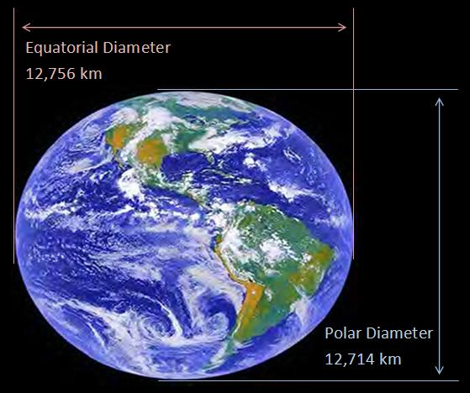

Equatorial Diameter
# Source: AI Source: Provided by: [Data Path: Persons Table -> ID Column: 1, Name_En Column: Motasem Essam] -> From: [ChatGPT] on [7/25/2026]
The diameter measured across the equator, through the center and perpendicular to the polar axis.
For an oblate spheroid, the equatorial diameter is greater than the polar diameter.

Key Characteristics
# Source: AI Source: Provided by: [Data Path: Persons Table -> ID Column: 1, Name_En Column: Motasem Essam] -> From: [ChatGPT] on [7/25/2026]
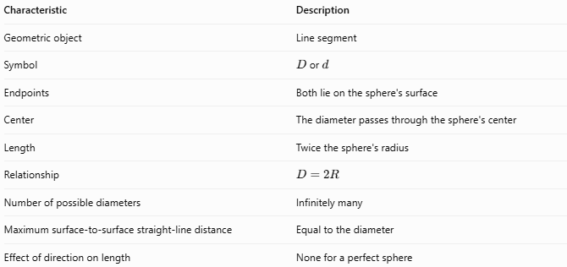
Characteristic | Description
Geometric object | Line segment
Symbol | $D$ or $d$
Endpoints | Both lie on the sphere's surface
Center | The diameter passes through the sphere's center
Length | Twice the sphere's radius
Relationship | $$D=2R$$
Number of possible diameters | Infinitely many
Maximum surface-to-surface straight-line distance | Equal to the diameter
Effect of direction on length | None for a perfect sphere

Mathematical Formulas

Diameter from Radius
# Source: AI Source: Provided by: [Data Path: Persons Table -> ID Column: 1, Name_En Column: Motasem Essam] -> From: [ChatGPT] on [7/25/2026]
$$\boxed{D=2R}$$
where $D$ is the diameter and $R$ is the radius.

Radius from Diameter
# Source: AI Source: Provided by: [Data Path: Persons Table -> ID Column: 1, Name_En Column: Motasem Essam] -> From: [ChatGPT] on [7/25/2026]
$$\boxed{R=\frac{D}{2}}$$

Sphere Surface Area Using Diameter
# Source: AI Source: Provided by: [Data Path: Persons Table -> ID Column: 1, Name_En Column: Motasem Essam] -> From: [ChatGPT] on [7/25/2026]
The surface area of a sphere is:
$$A=4πR^{2}$$
Since $R=D/2$:
$$A=4π{\left(\frac{D}{2}\right)}^{2}$$
Therefore:
$$\boxed{A=πD^{2}}$$

Sphere Volume Using Diameter
# Source: AI Source: Provided by: [Data Path: Persons Table -> ID Column: 1, Name_En Column: Motasem Essam] -> From: [ChatGPT] on [7/25/2026]
The volume of a sphere is:
$$V=\frac{4}{3}πR^{3}$$
Substituting $R=D/2$:
$$V=\frac{4}{3}π{\left(\frac{D}{2}\right)}^{3}$$
Therefore:
$$\boxed{V=\frac{πD^{3}}{6}}$$

Diameter in Coordinate Geometry
# Source: AI Source: Provided by: [Data Path: Persons Table -> ID Column: 1, Name_En Column: Motasem Essam] -> From: [ChatGPT] on [7/25/2026]
For two opposite endpoints $A\left(x_{1},y_{1},z_{1}\right)$ and $B\left(x_{2},y_{2},z_{2}\right)$ of a diameter:
$$\boxed{D=\sqrt{{\left(x_{2}-x_{1}\right)}^{2}+{\left(y_{2}-y_{1}\right)}^{2}+{\left(z_{2}-z_{1}\right)}^{2}}}$$
The sphere's center is the midpoint of the diameter endpoints:
$$\boxed{O=\left(\frac{x_{1}+x_{2}}{2},\frac{y_{1}+y_{2}}{2},\frac{z_{1}+z_{2}}{2}\right)}$$

Worked Examples
# Source: AI Source: Provided by: [Data Path: Persons Table -> ID Column: 1, Name_En Column: Motasem Essam] -> From: [ChatGPT] on [7/25/2026]
Example 1 — Finding the Diameter
A sphere has a radius of $7\text{ cm}$. Find its diameter.
Solution:
$$D=2R$$
$$D=2\left(7\right)$$
$$\boxed{D=14\text{ cm}}$$
Example 2 — Finding the Radius
A sphere has a diameter of $24\text{ m}$. Find its radius.
Solution:
$$R=\frac{D}{2}$$
$$R=\frac{24}{2}$$
$$\boxed{R=12\text{ m}}$$
Example 3 — Finding Surface Area from Diameter
A sphere has a diameter of $10\text{ cm}$. Find its surface area.
Solution:
Use the diameter formula:
$$A=πD^{2}$$
$$A=π{\left(10\right)}^{2}$$
$$\boxed{A=100π{\text{ cm}}^{2}}$$
Approximately:
$$A≈314.16{\text{ cm}}^{2}$$
Example 4 — Finding Volume from Diameter
A sphere has a diameter of $6\text{ cm}$. Find its volume.
Solution:
$$V=\frac{πD^{3}}{6}$$
$$V=\frac{π{\left(6\right)}^{3}}{6}=\frac{216π}{6}$$
$$\boxed{V=36π{\text{ cm}}^{3}}$$
Approximately:
$$V≈113.10{\text{ cm}}^{3}$$

Sphere Diameter vs. Related Concepts
# Source: AI Source: Provided by: [Data Path: Persons Table -> ID Column: 1, Name_En Column: Motasem Essam] -> From: [ChatGPT] on [7/25/2026]
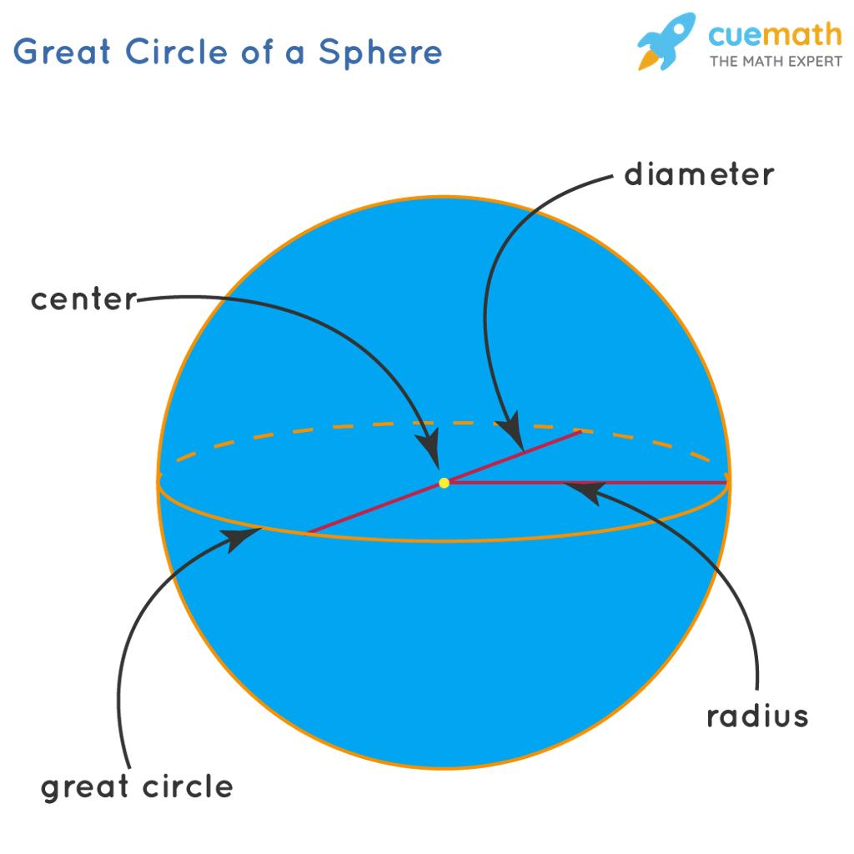
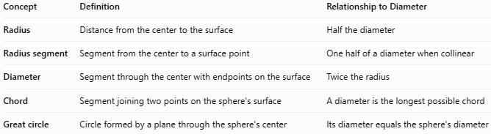
Concept | Definition | Relationship to Diameter
Radius | Distance from the center to the surface | Half the diameter
Radius segment | Segment from the center to a surface point | One half of a diameter when collinear
Diameter | Segment through the center with endpoints on the surface | Twice the radius
Chord | Segment joining two points on the sphere's surface | A diameter is the longest possible chord
Great circle | Circle formed by a plane through the sphere's center | Its diameter equals the sphere's diameter

Applications
# Source: AI Source: Provided by: [Data Path: Persons Table -> ID Column: 1, Name_En Column: Motasem Essam] -> From: [ChatGPT] on [7/25/2026]
Sphere diameter is used in:
- Manufacturing: Specifying the size of balls, bearings, and spherical components.
- Engineering: Calculating dimensions and clearances.
- Astronomy: Describing the sizes of planets, stars, and other approximately spherical objects.
- Geometry: Calculating sphere surface area and volume.
- Measurement: Determining a sphere's size from its radius or circumference.
For example, if a spherical ball has a diameter of $8\text{ cm}$, its radius is $4\text{ cm}$, allowing its surface area and volume to be calculated.

Key Points
# Source: AI Source: Provided by: [Data Path: Persons Table -> ID Column: 1, Name_En Column: Motasem Essam] -> From: [ChatGPT] on [7/25/2026]
- A diameter passes through the center of a sphere.
- Both endpoints lie on the sphere's surface.
- The diameter is twice the radius: $D=2R$.
- The radius is half the diameter: $R=D/2$.
- A perfect sphere has infinitely many diameters, all of equal length.
- The diameter is the longest straight-line chord of a sphere.
- The formulas $A=πD^{2}$ and $V=πD^{3}/6$ allow surface area and volume to be calculated directly from diameter.

Conclusion
# Source: AI Source: Provided by: [Data Path: Persons Table -> ID Column: 1, Name_En Column: Motasem Essam] -> From: [ChatGPT] on [7/25/2026]
The sphere diameter is the line segment connecting two opposite points on a sphere's surface through its center. It is a fundamental measurement because it determines the sphere's radius and can be used to calculate its surface area and volume.

